**Lab1**

**Prepared by Andrew Auxier**

**Prepared for Professor Carl Eyler**

**SDEV 300 6383 Building Secure Python Applications (2235)**

**University of Maryland Global Campus**

**2023-05-24 (UTC+9)**

## Test Table

| **Test Case** | **Input** | **Expected**  **Output** | **Actual**  **Output** | **Pass**  **(yes/no)** |
| --- | --- | --- | --- | --- |
| **1a** | **No** | **Program exit** | **Program exit** | **yes** |
| **1b** | **Yes, 111, exit** | **Proceed, integer input denied, program exit** | **Proceed, integer input denied, program exit** | **yes** |
| **1c** | **yes, fish, mcfish, exit** | **Proceed, successful name inputs and print out, program exit** | **Proceed, successful name inputs and print out, program exit** | **yes** |
| **2a** | **17** | **Underage input terminates the program** | **Underage input continued to loop, program terminated by the tester** | **no** |
| **2a-1** | **17** | **Underage input terminates the program** | **Underage input terminates the program** | **yes** |
| **2b** | **exit** | **User terminates program** | **User terminates program** | **yes** |
| **3** | **no** | **The user is not a citizen, and the program terminates** | **The user is not a citizen, and the program terminates** | **yes** |
| **All exits follow the same exact code and work, no longer being tested, only positive, negative, and/or validation.** | | | | |
| **3a** | **11111** | **Validation loop entered** | **Validation loop entered** | **yes** |
| **3b** | **yes** | **The validation loop passed, the program continues to the next step** | **The validation loop passed, the program continues to the next step** | **yes** |
| **3c** | **zq, zqq, z11, ==, FL** | **Validation loop due to invalid entries, FL ends loop** | **Validation loop due to invalid entries, FL ends loop** | **yes** |
| **4** | **111111, aaaaa, aa111, *****, 12345** | **Validation loop due to invalid entries, 12345 ends loop, program displays end message and terminates gracefully** | **Validation loop due to invalid entries, 12345 ends loop, program displays end message and terminates gracefully** | **yes** |

**Authors Note: None that I can think of. This is here simply to ensure future author’s notes are included in this as the document will be used as a template for future testing in assignments.**

# Screenshots

## 1a

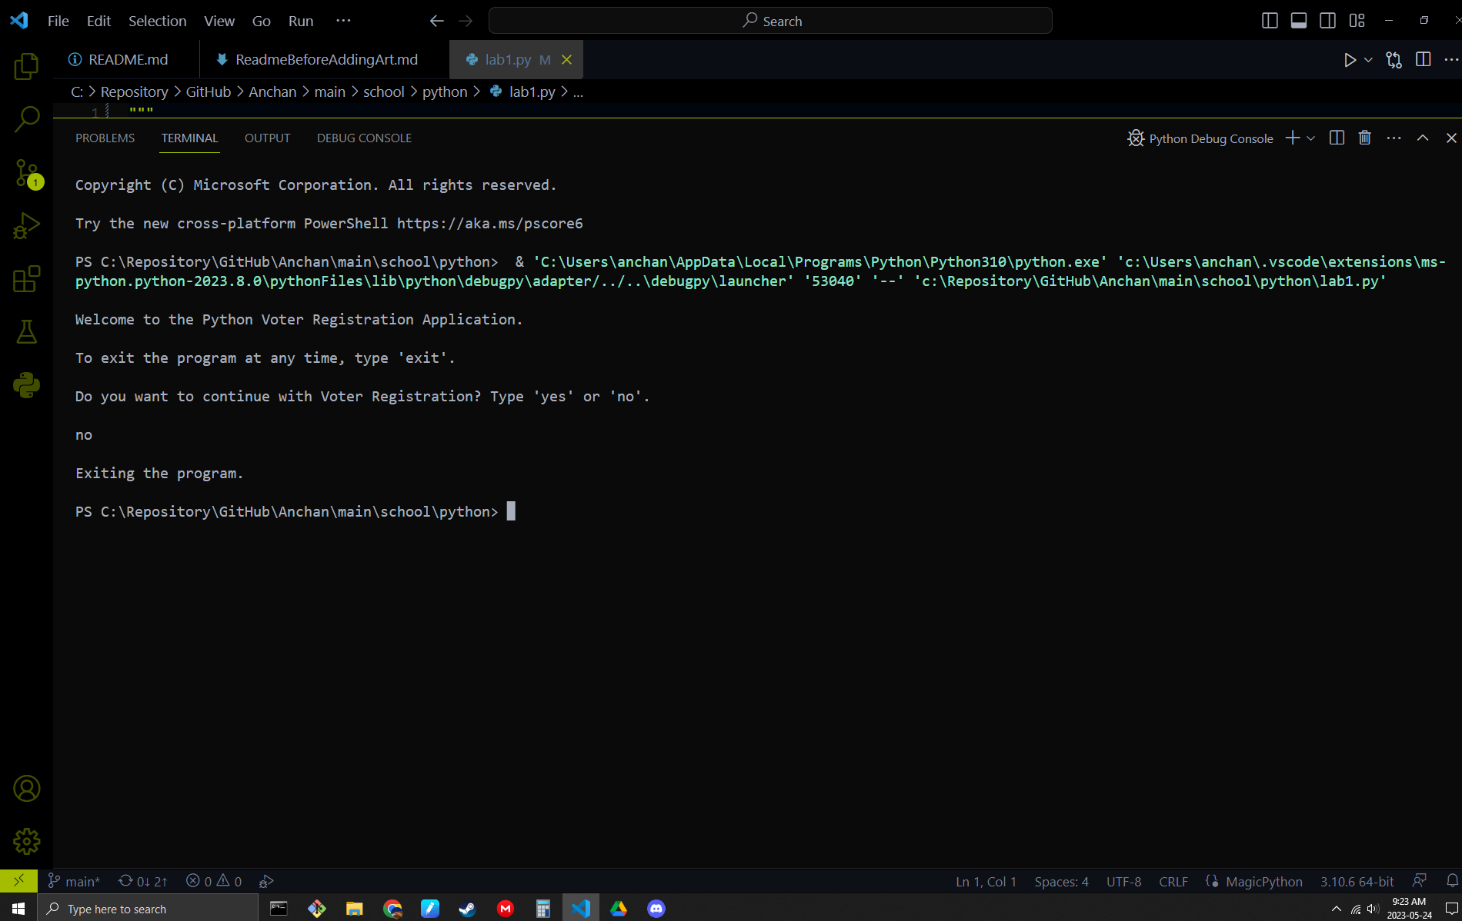

## 1b

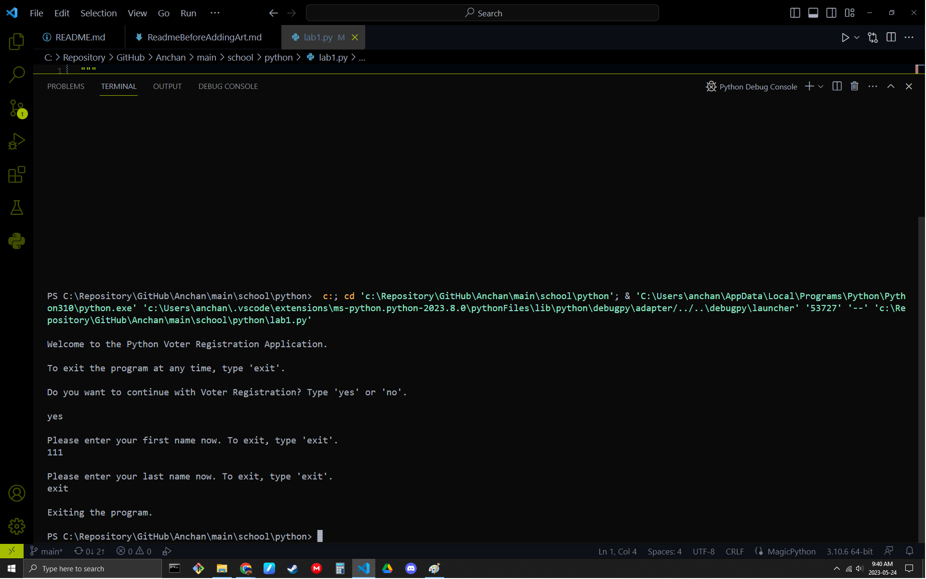

## 1c

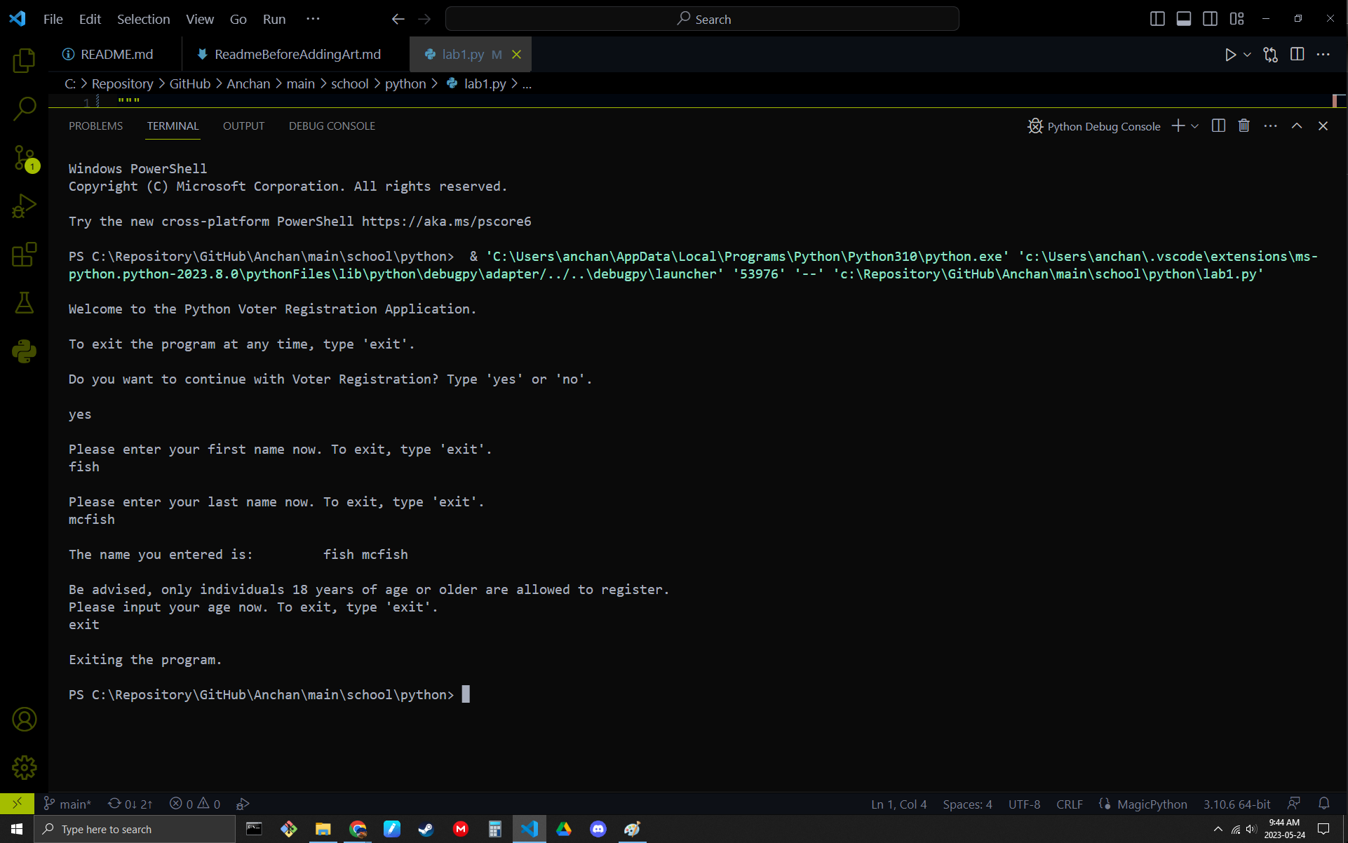

## 2a

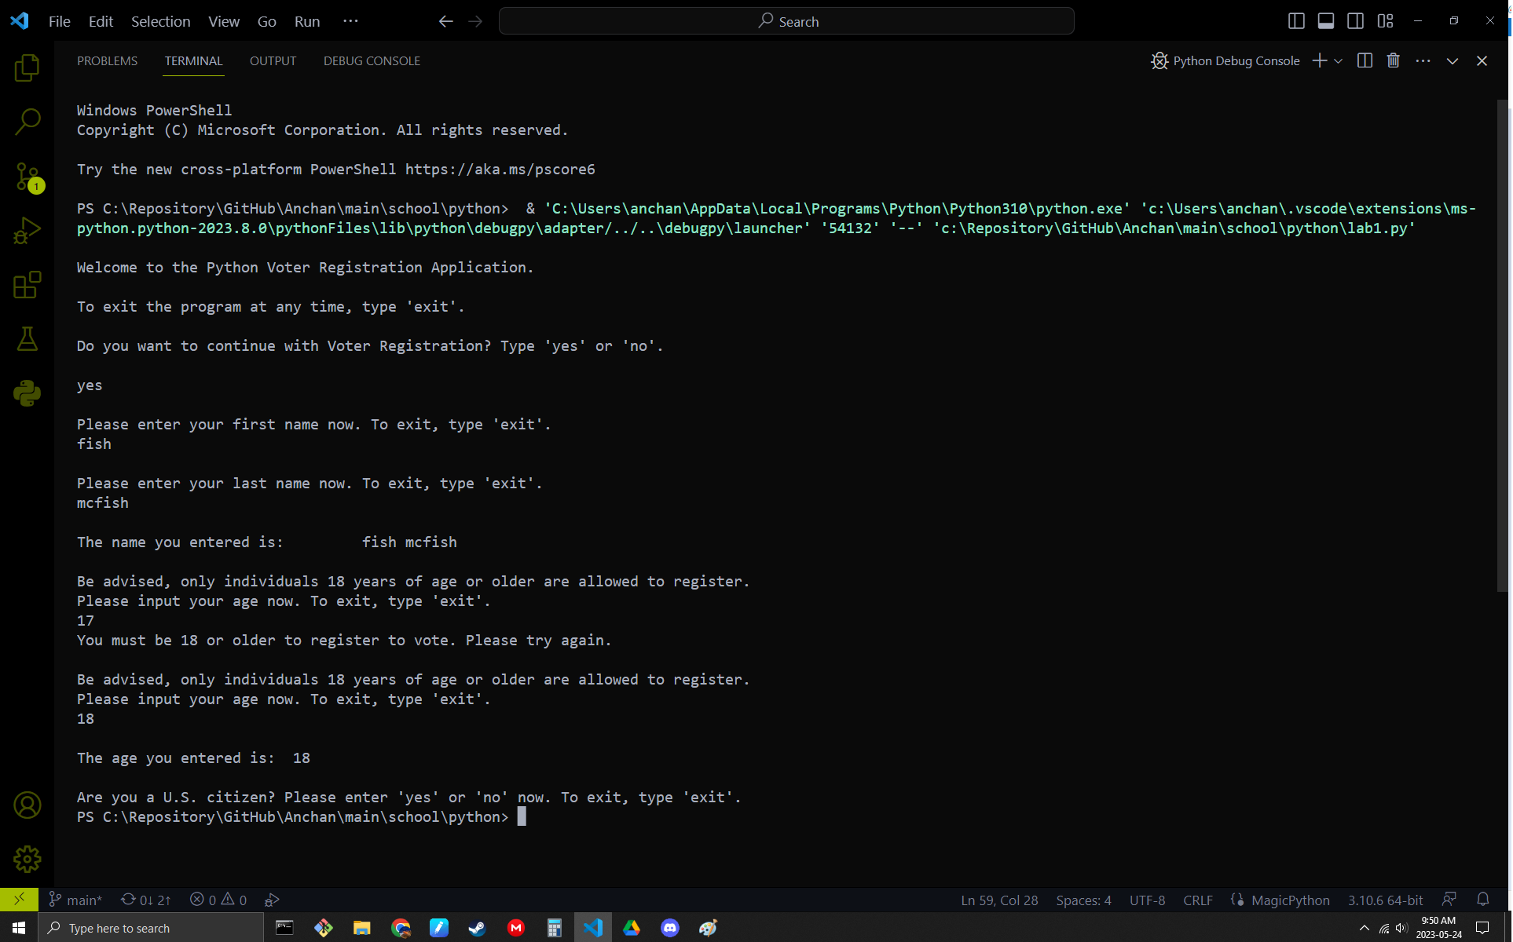

## 2a-1

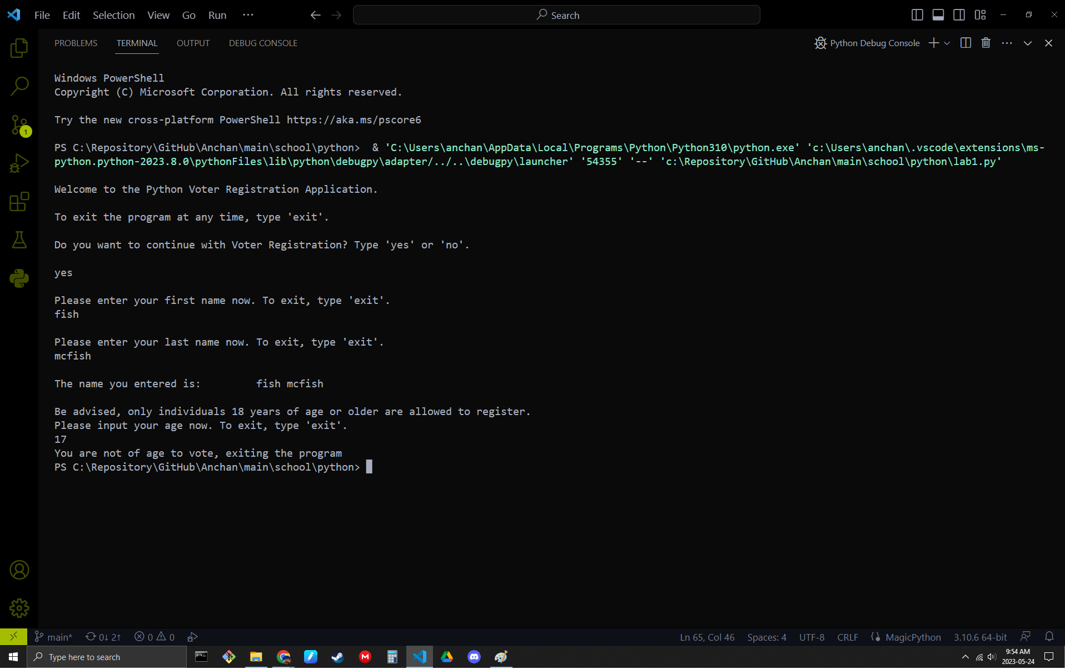

## 2b

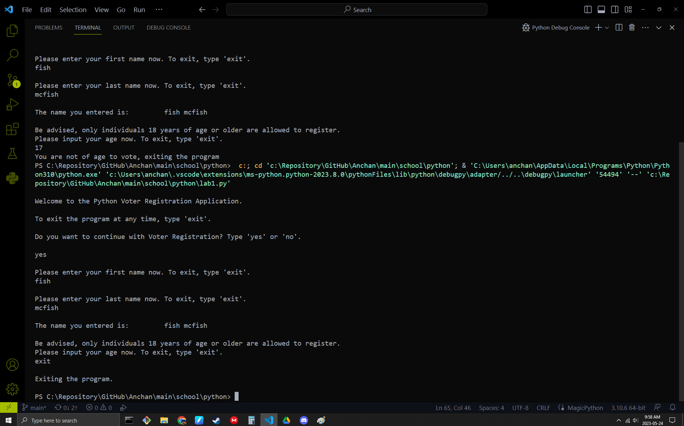

## 3

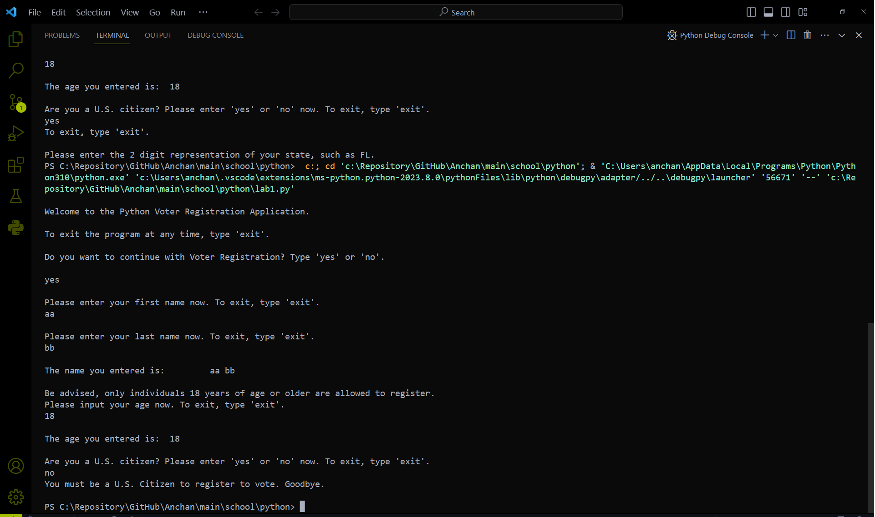

## 3a

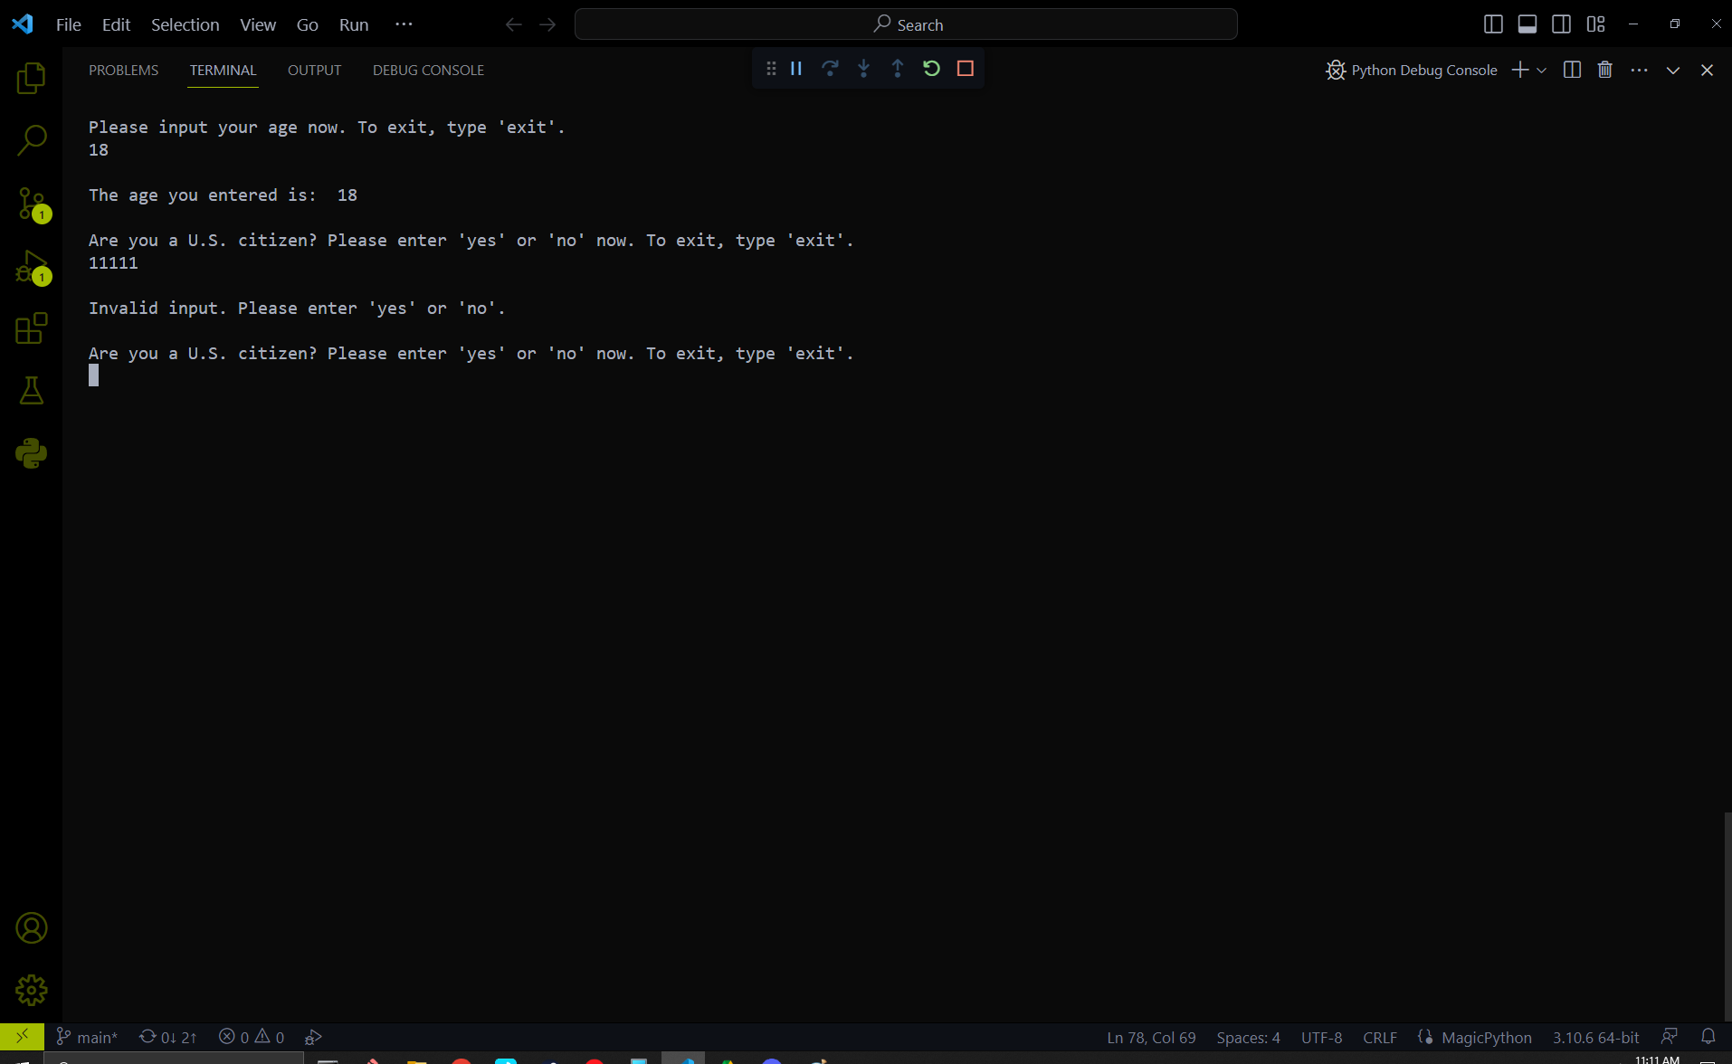

## 3b

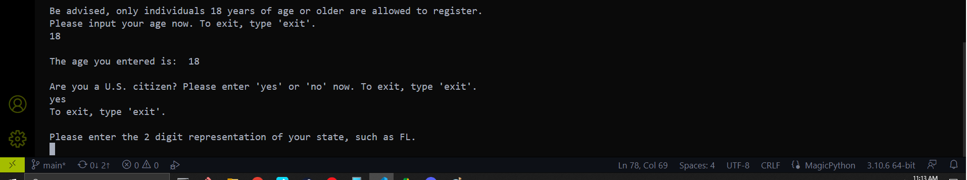

## 3c

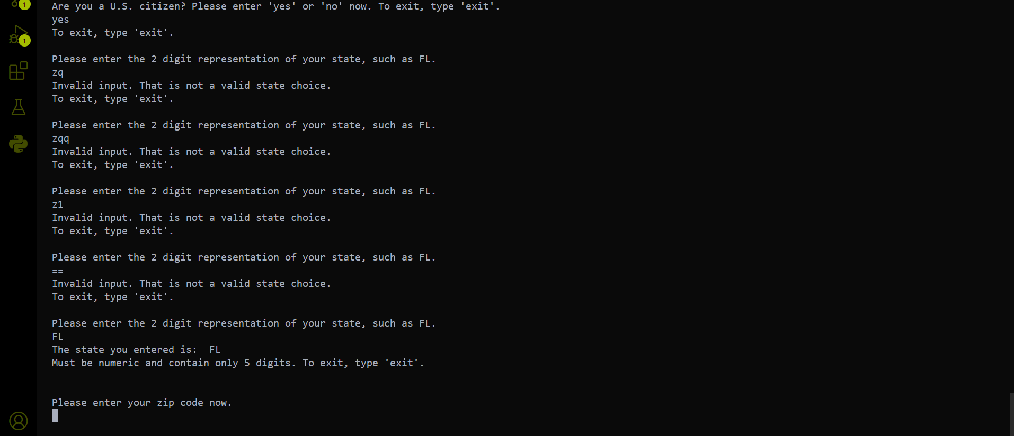

## 4

